Pokhara University

Level: Bachelor | Semester – Spring | Year : 2007
Programme: BE |  | Full Marks: 100
Course: Network Theory |  | Time : 3hrs.

Candidates are required to give their answers in their own words as far as practicable.
The figures in the margin indicate full marks.

Attempt all the questions.

 | - In the given circuit switch 'K' is closed at t = 0, finds 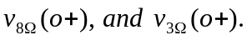  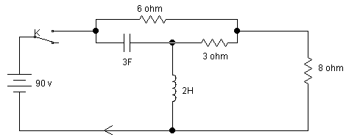  - In the given RLC parallel circuit, determine 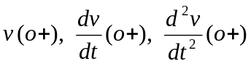  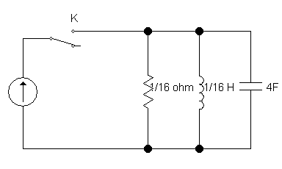  V | 7  8
 | - Derive an expression for current i(t) for second order network consisting of resistance R inductance L Henry and capacitance C Farad when a step voltage of V volts is applied at time t = 0. Determine the natural frequency and damping coefficient of the network. Also sketch i(t).  - A sinusoidal voltage 25 sin 10t is applied at time t = 0 to a series R-L circuit comprising R = 5Ω and L = 1H. By the method of Laplace transformation, find current i(t). Assume zero current through inductor before application of voltage. | 8  7
 | - State initial and final value theorems of Laplace transform. Find i(0) and steady state value of i(t) for the function 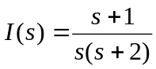.  - Check the stability of following polynomial using Routh-Hurwitz Criterion:  P(s) = s⁴+2s³+4s²+12s+10 | 7  8
 | - Plot the poles and zeros in s-plane for the network function:  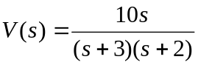  Also, obtain v(t) using pole-zero diagram.  - For the following periodic waveform, find the Fourier series expansion.  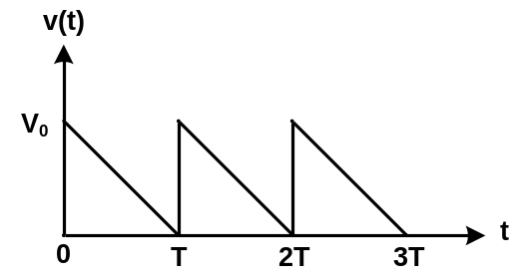 | 8  7
 | - Draw the Bode diagram for the given network function: 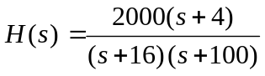  - Check the positive-realness of the network function:  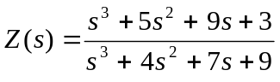 | 8  7
 | - An impedance is given by 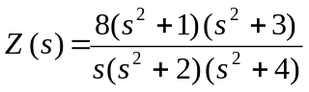. Realise the network in Cauer-II form.  - Find the short circuit admittance parameters of the following two port network. All resistors are in ohm.  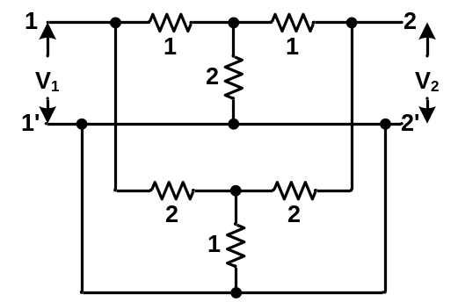 | 8  7
 | Write short notes on (Any Two):  - Transient and steady state response  - Reciprocity and symmetry of a two port network  - Ideal and practical filters | 2×5

